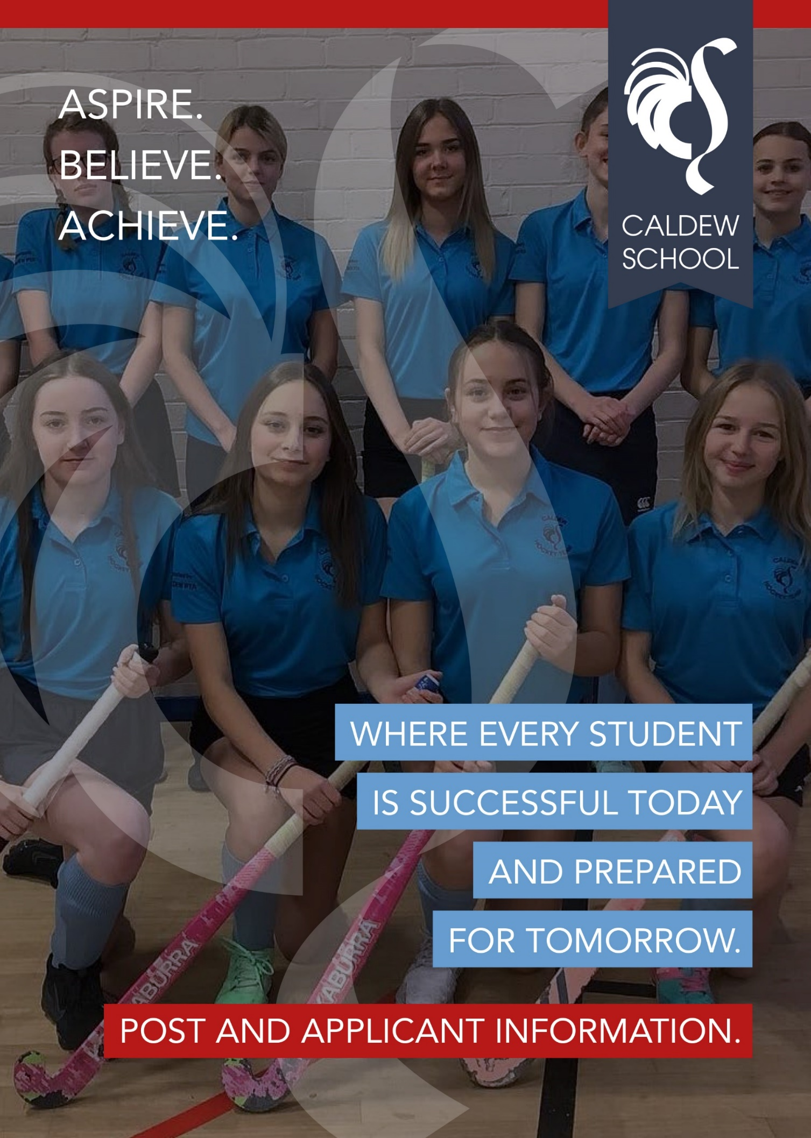
TEACHER OF English

Salary: MPS/UPS
Contract Term: Part Time (0.6 FTE), permanent
Start date: September 2026

Closing date: Wednesday 3rd June
Interview date: w/c 8th June

Advert:
We are seeking to appoint an ambitious, innovative and highly effective Teacher of English who is passionate about inspiring young people and securing excellent outcomes across the full age and ability range.
The successful candidate will join a well-established, well-resourced and highly collaborative department, which delivers English at KS3, and English Language and English Literature at GCSE and A Level. You will play a key role in delivering high-quality teaching, contributing to a well-sequenced curriculum and supporting strong outcomes for all students.
This is an exciting opportunity for both Early Career Teachers and experienced practitioners. We are looking for someone with strong subject knowledge, a commitment to high-quality teaching, and a desire to continually develop their practice.
At Caldew School, we are proud of our improving outcomes and positive academic record. We are committed to building on this success through a relentless focus on high expectations, curriculum coherence and adaptive teaching. As a Teacher of English, you will contribute to this work, ensuring consistency of practice and high standards in your classroom.

Safeguarding Statement
Caldew School is committed to the protection and safety of its pupils and expects all staff and volunteers to share this commitment. An online search will be carried out for shortlisted candidates. The successful applicant will be required to undertake a criminal record check via the DBS. Our safeguarding policy can be found at:
https://caldew.cumbria.sch.uk/our-school/policies-documents/

Equal Opportunities Statement
We are an equal opportunity employer. We want to develop a more diverse workforce and we welcome applicants from all sections of the community. Applicants with disabilities will be granted an interview if the essential job criteria are met. We are committed to employing disabled people making reasonable adjustments to support applicants when required
Application Process
Please return a completed application form in full ensuring you have provided accurate information, including the names, addresses and relevant contact details of two referees together with your letter of application.
The letter of application should be no more than two sides of A4 and should set out the particular strengths that you would bring to the post and how you feel you meet the criteria outlined in the job description and person specification

Short listed applicants may be screened prior to interview by checking social media. The purpose of this is to ascertain if the applicant demonstrates behaviour that is suitable for employment in a school environment. References will be requested prior to interview.
We are committed to safeguarding and promoting the welfare of children and young people and expects all employees and volunteers to share this commitment. An application for a DBS certificate will be submitted for all candidates once they have been offered the position. For posts in regulated activity, the DBS check will include a barred list check. During the recruitment process, any offences, or other matters relevant to the position will be considered on a case-by-case basis. Any offer of employment will be subject to receipt of a satisfactory DBS Enhanced Disclosure.

DEPARTMENT INFORMATION:
There is a strong ethos of ambition within the English department, with improving teaching and learning at its heart. The team consists of both full and part time teachers; some also hold other responsibilities within the school. The team is led by the Head of Department and an Assistant Head of Department, as well as a Lead Practitioner for English.

Studying English at Caldew allows learners to experience a range of texts that will challenge and inspire them. We aim to develop our students’ understanding of the rich world around them by discovering the links that Cumbria has to classic genres and great works of literature, alongside works of wider global and cultural significance. Students explore fiction, non-fiction and poetry through thematic units centred on significant texts, in which they are supported to develop their ideas through speaking as well as writing. We give a particular focus to creative writing, offering students the opportunity to explore themes and ideas through their own creativity and building their confidence when using ambitious vocabulary. We aim to foster a love of reading, writing and all things English related through our enthusiasm for our subject and our well-planned curriculum. We want our students to be confident, assured learners with a depth of knowledge to support their understanding of the world around them.

At Key Stage 4, students follow AQA’s English Language & English Literature specifications. At Key Stage 5, the department delivers AQA’s English Language and EdExcel’s English Literature courses, with the EdExcel combined English Language & English Literature course being used in some years.
We are ambitious to achieve the best for all students and, as a department, we engage with pedagogical research and dedicate our subject development time to exploring, implementing and reflecting on agreed teaching and learning strategies. We are a team of supportive and friendly colleagues who enjoy our subject, work collaboratively and strive to ensure the very best for our students.

Job Description:

Job Title: Teacher of English
Reports To: Head of Department

Purpose of the Role:
The Teacher will deliver high-quality teaching, ensuring a well-sequenced curriculum is implemented effectively and that students achieve strong outcomes across Key Stages.
The role involves planning and delivering high-quality lessons, contributing to curriculum delivery, maintaining consistently high standards in the classroom, and ensuring that all students, regardless of starting point, are supported to make strong progress and achieve well.

Key Responsibilities
1. Teaching and Learning
Deliver consistently high-quality teaching across Key Stages, ensuring lessons are well-structured and engaging.
Plan and deliver lessons that are challenging and rooted in strong subject knowledge.
Implement a consistent approach to adaptive teaching to meet the needs of all learners, including SEND, disadvantaged and High Prior Attainers.
Ensure a strong focus on securing strong outcomes through evidence-informed teaching.
Promote high expectations of behaviour, effort and presentation in all lessons.

2. Professional Development (CPD)
Engage fully in high-quality CPD in line with whole-school priorities.
Actively reflect on and develop teaching practice through coaching and feedback.
Develop subject knowledge and pedagogy to improve classroom practice.
Take responsibility for identifying personal development needs and acting upon them.

3. Coaching and Mentoring
Engage positively with coaching and feedback to improve teaching practice.
Work collaboratively with colleagues to plan, deliver and refine lessons.
Support and contribute to a culture of professional learning within departments.
Where appropriate, support Early Career Teachers (ECTs) or trainees.

4. Data and Performance Monitoring
Monitor student progress and attainment across classes and key groups.
Use assessment effectively to identify gaps in knowledge and address misconceptions.
Contribute to the implementation of Key Assessment Tasks (KATs) and use outcomes to inform teaching.
Implement interventions to support students who are underperforming.
Ensure all groups of students, including disadvantaged, SEND and High Prior Attainers, make strong progress.

5. Team Collaboration and Contribution
Contribute positively to departmental and whole-school priorities.
Work collaboratively with colleagues to ensure consistency in curriculum delivery and teaching.
Support the implementation of departmental plans and agreed approaches.
Engage in quality assurance processes, including learning walks, work samples and student voice.
Share good practice and contribute to a culture of professional learning.
Uphold high expectations, professionalism and a commitment to continuous improvement.

TEACHING STAFF
Teachers at Caldew School work within the requirements of the School Teachers’ Pay and Conditions Document (STPCD). All teaching staff are expected to implement school policies consistently to ensure the smooth and effective running of the school.
They contribute to the delivery of the school’s long-term aims through high-quality teaching, curriculum implementation and ongoing professional development. Staff are expected to make a full contribution to the wider life of the school in order to secure the best possible outcomes for students.
All teachers at Caldew School are committed to ensuring that students know more and remember more over time, through a consistent focus on high expectations, strong curriculum delivery and effective teaching.

All teaching staff are required to attend meetings with colleagues, students, parents and governors as directed within the school calendar. Directed time will not exceed 1265 hours, or the pro-rata equivalent.

All staff are expected to meet the Teachers’ Standards (2013) and demonstrate the highest standards of professionalism, conduct, appearance and commitment within the school and wider community.
Note: The duties required of all teachers under Pay and Conditions legislation form part of this job description. This document is not exhaustive and will be reviewed annually and may be amended following consultation.

FORM TUTOR - Key Responsibilities
- Ensure that all students are ready to learn by maintaining high expectations around attendance, punctuality, conduct, uniform and equipment.
- Actively monitor and support students’ academic progress through effective mentoring and regular review.
- Support, advise and encourage students to raise aspirations and achieve their potential.
- Act as a key point of communication between home and school.
- Celebrate student achievement, both informally and through the school’s reward systems.
- Deliver effective mentoring and coaching, particularly at key reporting points.
- Monitor attendance and punctuality, addressing concerns promptly and effectively.
- Track students’ progress across subjects, challenging underachievement and supporting improvement.
- Promote engagement in enrichment, extra-curricular activities and wider school life.

CLASSROOM TEACHER
Job Description
Teachers enable students to make strong progress over time through consistently high-quality teaching and curriculum delivery by:
- Meeting the minimum standards set out for teachers and working at a level appropriate to their experience and salary level;
- Fulfilling all aspects of the Standards for Teachers which will be monitored annually as part of the Appraisal process;

Part one: The Standards for Teachers are detailed under the following points. (Teachers must familiarise themselves with the underlying detail of each point):
- Setting high expectations which inspire, motivate and challenge students;
- Promoting good progress and outcomes in every lesson;
- Keeping abreast of developments in subject and curriculum knowledge;
- Planning and teaching well-structured lessons;
- Adapting teaching to respond to the strengths and needs of all students;
- Making accurate and productive use of assessment;
- Managing behaviour effectively to ensure a good and safe learning environment;
- Fulfilling the wider professional responsibilities as required by the school.

Part two: Personal and Professional Conduct
- Upholding public trust in the profession and maintain high standards of ethics and behaviour, within and outside school;
- Having proper and professional regard to the ethos, policies and practices of the school in which they teach, and maintain high standards in their own attendance and punctuality;
- Having an understanding of and always act within, the statutory frameworks which set out their professional duties and responsibilities.

Person Specification:
QUALIFICATIONS
Essential | Desirable | Evidence
Good honours degree in relevant subject | Further relevant qualifications | Application, References
Qualified Teacher Status (QTS) or ITT trainee | Evidence of professional development | Application, References
Recognised teaching qualification (PGCE/BEd) |  | Application, References

EXPERIENCE AND SKILLS SPECIFIC TO TEACHING
Essential | Desirable | Evidence
Teaching KS3 and KS4 | Experience teaching KS5 | Application, References, Teaching Task, Interview
Strong subject knowledge and enthusiasm | Experience in more than one school | Application, References, Teaching Task, Interview
High-quality teaching securing outcomes |  | Application, References, Teaching Task, Interview
Use of adaptive teaching |  | Application, References, Teaching Task, Interview
Commitment to inclusion |  | Application, References, Teaching Task, Interview
Pastoral contribution |  | Application, References, Teaching Task, Interview

CURRICULUM UNDERSTANDING
Essential | Desirable | Evidence
Knowledge of curriculum and exam specs | Awareness of whole-school priorities | Application, Teaching Task, Interview
Understanding of sequencing | Experience of curriculum development | Application, Teaching Task, Interview
Deliver well-structured curriculum |  | Application, Teaching Task, Interview
Use assessment effectively |  | Application, Teaching Task, Interview
Commitment to curriculum development |  | Application, Teaching Task, Interview

CONTINUED PROFESSIONAL DEVELOPMENT
Essential | Desirable | Evidence
Commitment to CPD | Experience contributing to curriculum | Application, Interview
Reflect on practice and respond to feedback | Supporting trainees/ECTs | Application, Interview
Contribute to department and school |  | Application, Interview
Collaborative working |  | Application, Interview

INTERPERSONAL SKILLS
Essential | Desirable | Evidence
Strong communication | Confidence sharing practice | Application, Interview, Teaching Task, References
Build relationships |  | Application, Interview, Teaching Task, References
Team working |  | Application, Interview, Teaching Task, References

PERSONAL QUALITIES
Essential | Desirable | Evidence
Professionalism and resilience | Extra-curricular contribution | Interview, References
Commitment to outcomes |  | Interview, References
High expectations |  | Interview, References
Initiative and adaptability |  | Interview, References
Safeguarding commitment |  | Interview, References

