

Dear Parent/Carer,

**Parent Governor Election**

I am writing to you to invite you to stand for election as a Parent Governor, or nominate another parent to do so. In our school we have provision for four Parent Governor and there are currently three vacancies.

No special qualifications are needed and the most important thing is to have a keen interest in the school and be prepared to play an active part in the Governing Body’s work. Training is available for all governors.

The enclosed Articles of Association (pages 23 – 25) summarises the circumstances under which someone cannot serve as a Governor. The Articles of Association can be found on the school website at - <https://www.caldew.cumbria.sch.uk/uploads/95/articles-of-association.pdf/>

Nominations must be from parents, or individuals exercising parental responsibility, of a child at Caldew School.

If you would like to stand for election please complete the enclosed nomination form and return it to the school no later than **Friday 27th September 2024**. You may also include a short personal statement to support your nomination, which should be no longer than 250 words. Self-nominations will be accepted but if you are nominating another parent, please seek their prior consent.

If there are more nominations than vacancies the election will be by secret ballot. If that is necessary, voting papers will be sent to all parents together with details of the ballot procedure.

Yours faithfully,

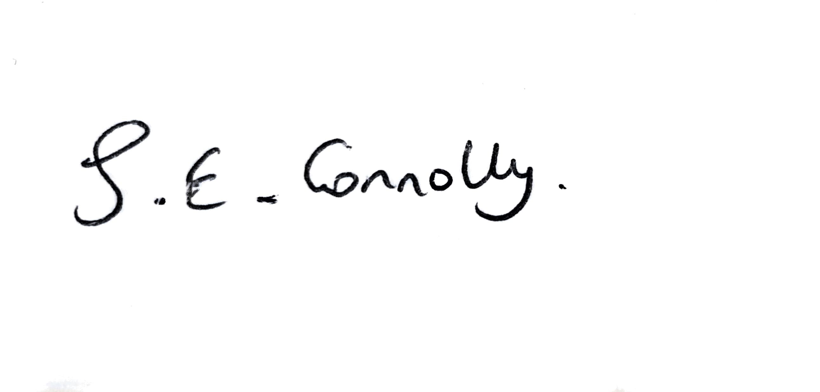

Sarah Connolly

Clerk to Governors



**Caldew School – Nomination of Parent Governor**

Please enter in BLOCK LETTERS, the name and address of the person being nominated for election:

Name: ___________________________________________________________________

Address:

_________________________________________________________________________

Signature of nominee: ________________________________________________

Signature of proposer (if not nominating self): ____________________________________

Name and address of proposer (if different to nominee):

_________________________________________________________________________

Personal Statement (maximum 250 words)

I wish to submit my nomination for the election of Parent Governor.

I confirm (i) that I am willing to stand as a candidate for election as a Parent Governor and

(ii) that I am not disqualified from holding office for any of the reasons set out in the articles of association.

Signature …………………………………………………………………………………………………….

Date …………………………………………………………………………………………………….

**Completed nomination forms must be returned to** [**sarah.connolly@caldew.cumbria.sch.uk**](mailto:sarah.connolly@caldew.cumbria.sch.uk)

**by Friday 27th September 2024.**