Autumn/Winter 2024

**Vaccination Clinics**

**The School Aged immunisation team are commissioned to deliver the national immunisation programme of**

**Nasal Flu, Diphtheria Tetanus, Polio, and Men ACWY and HPV and MMR in school**

**If your child missed the vaccination in school, there is the opportunity to get the vaccine at one of our catch-up clinics as detailed below:**

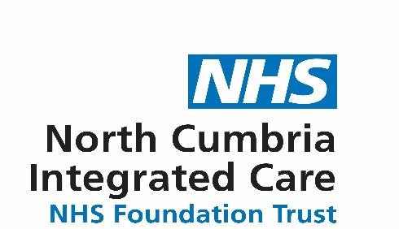

|  |
| --- |
| **BY APPOINTMENT ONLY**  **Penrith Area**  Penrith Hospital Tuesday – 8th October 2024 15.00 – 17.30pm  Penrith Hospital Tuesday – 19th November 2024 15.00 – 17.30pm  Appleby Children’s Centre Wednesday – 27th November 2024 15.00 – 17.30pm  Penrith Hospital Monday – 9th December 2024 15:00 - 17:30pm    **Carlisle**  London Community Centre – Tuesday 22nd October 2024 15.00 – 17.30pm  London Community Centre – Tuesday 12th November 2024 15.00 – 17.30pm  London Community Centre – Tuesday 3rd December 2024 15.00 – 17.30pm    To make an appointment or for further information, please contact the  Immunisation Team: 01228 608046  Email ncm-tr.northschoolagedimmunisationteam@nhs.net      There is an answerphone in operation if we are unable to take your call.  Please leave your name, contact number and child’s school details.  We will return your call as soon as possible. |

Safe, high quality care **every time** Safe, high quality care **every time**