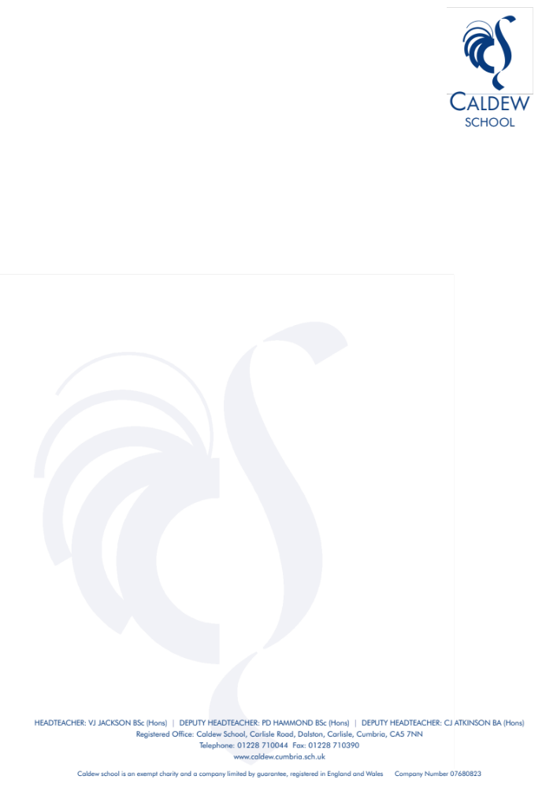
VJJ/HEV
12 October 2026

Dear Parents and Carers

As you are aware, the school had a full Ofsted Inspection on the 22nd and 23rd of September 2026 and I am delighted that I am now able to share the report with you.

I am very happy with this report and most importantly it sounds like our school. The inspectors spent a lot of time talking to students about their experiences at Caldew. I am very proud that inspectors have said that students “enjoy coming to this inclusive, friendly and caring school” and they feel “part of a community where staff get to know them quickly”. They trust staff to deal with concerns quickly and effectively, they value the range of enrichment opportunities available and that they feel their views are valued. It means a lot to all our staff that our young people spoke so positively about their school.

The report highlights many strengths, including that our students show positive attitudes to learning, that they rise to leaders’ high expectations of behaviour, are engaged and focused on their learning in lessons, achieve exam results in line with national averages and leave well prepared for the next stage of their education. The inspectors found that our curriculum is broad and ambitious. They noted that relationships between staff and students are a strength of the school. We were also very pleased that inspectors found that students benefit from a broad range of experiences that enable them to develop their interests and talents and that careers education at Caldew is of a high quality, including in the Sixth Form, and students benefit from participating in work-related learning that raise their ambitions and widens their horizons. They also recognised that we have developed highly productive links with local employers that enhance student’s personal development by running aspirational activities that open doors to opportunities for the future for students across the whole school. I am proud that the inspectors recognised that we support students with SEND well so that they can access the same learning as others and progress well.

We are obviously very pleased with this report that recognises the improvements that have been made at the school since the last inspection.

Since the last inspection in 2022, OFSTED have changed the way that they grade schools. There is now no overall grade and instead a grade is given for 7 separate sections. The wording of the grades has also changed. Expected standard is the grade that describes when a school is doing everything it should be doing. OFSTED describes this as a high bar and say that the new grades cannot be compared to the old ones. Safeguarding is either met or not met.

I am really pleased that we have been awarded “Expected Standard” in all areas.

Safeguarding Met
Achievement Expected Standard
Attendance and Behaviour Expected Standard
Curriculum and Teaching Expected Standard
Inclusion Expected Standard
Leadership and Governance Expected Standard
Personal development and Wellbeing Expected Standard
Post 16 Provision (Sixth Form) Expected Standard

During the feedback session from inspectors they commented that we met some of the ‘strong’ criteria in all of the inspection areas. They also praised our students for their good behaviour and politeness during the inspection.

I would also like to thank the staff at the school for all of their hard work over the past few years that has resulted in such a positive report, and their commitment to helping our young people be successful.

The report does identify three areas where we need to improve and it was encouraging that the inspection team identified the same issues that we, as a school, had already identified and are included in our School Improvement Plan. These areas are:

- Leaders should continue their work to secure greater consistency in the quality of work. In particular, by ensuring that students are given more opportunities to deepen their knowledge and understanding across the curriculum.
- Leaders should build on improvements to further reduce persistent absence among disadvantaged students
- Leaders should deepen students’ knowledge of fundamental British values and of protected characteristics so that they can speak more knowledgeably about these aspects of modern Britain.

Please be assured that we continue to be committed to improving our school and that we will not become complacent. We know that there are areas where we can improve and we are determined to give every child who attends Caldew School the best education possible.

I would like to thank you for all of your support over the past few years, which I personally value and which continues to inspire me and my wider team. I would also like to take this opportunity to say thank you to all of you who completed OFSTED’s Parent View survey, which was extremely positive and to those of you who sent us messages of support. I am looking forward to continuing working with you to secure the highest possible standards for your children and our students so that, at Caldew, we become the very best we can be.

Yours sincerely

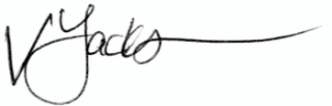

Vicki Jackson
Headteacher

